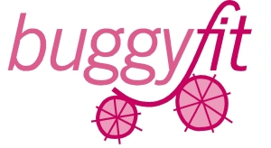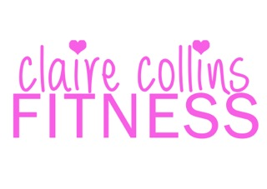
Post Natal Exercise Consent Form
Data Protection: The information you provide will only be used by Claire Collins Fitness, and will not be shared with any third party without your prior permission.
Date:
Name: DOB:
Address:

Mobile Number:
Email Address:
Baby name: Baby DOB:

Previous Exercise: (briefly outline)

Please circle if you have experienced any of the following, past or present:-

Shortness of breath Heart Disease Diabetes
Chest Pain Hypoglycaemia Multiple births
Miscarriage Pelvic/abdominal cramps High/Low blood pressure
Eating Disorder Vaginal bleeding Knee problems
Vaginal Disorder Arthritis Back problems
Blood Disorder Dizziness Neck problems
Prolaspe Abdominal Separation Incontinence

Is there anything in your medical history you feel could affect your ability to exercise?

Are you taking any medication? (please give details)

Is there anything about your pregnancy or birth you feel is relevant to the participation in an exercise programme?

What are your goals or reasons for participating in exercise?

Type of Birth?

Are you Breast Feeding?

How much sleep are you getting?

Are you currently participating in any other exercise?

I, acknowledge and confirm that I have had the all clear by my GP to commence suitable postnatal exercise. I am aware that I must feel well prior to each class and will notify you (the trainer) should I feel unwell at any time during the class.
Whilst I am aware that every effort has been taken to ensure this exercise class is suitable for postnatal women. I understand that my participation and the safety of both my child/children and myself are my responsibility.
I shall inform my instructor of any medical or post-natal related changes prior to commencing each training session and that either the instructor or Buggyfit will not be liable in any way for any unforeseen circumstances or for any circumstances of which I should have been aware but failed to notify them.

Please be aware we do not advocate running with a buggy at Buggyfit.

Social media is a great promotional platform for us- We may take informal photos or video at class to help with our promotion, but we respect your wishes so please delete appropriately.
I am happy for you to use pictures of me yes□ no□ and of my Baby & children yes□ no□
I hereby consent for you to process and store my information for at least 7 years for professional and legal purposes and my consent will be sought before it is shared with anyone else.
I understand that these details may be shared in the event of a medical emergency.
I give / do not give you permission to contact me via email/mobile phone for marketing purposes in the future.
I give / do not give you permission to contact me via email/mobile phone re Buggyfit class information & social events.
I confirm that all statements on the form are correct and that I have read and understand this declaration.

Signed:……………………………………………………Print…………………………………….

Date:…………………………… Trainers signature……………………………………….

